Idaho Falls American Legion Post 56 Supports
Idaho Falls School District 91
Fifth Grade Patriotic Program

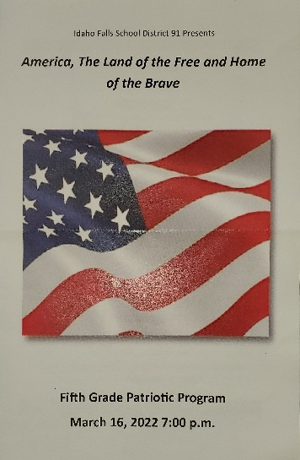
On March 16, 2022, Idaho Falls School District 91 held an amazing Fifth Grade Patriotic Program at Skyline High School. The Fifth Graders were well rehearsed and sung from their hearts of the love they have for our country, the United States of American, and all that is good about it.

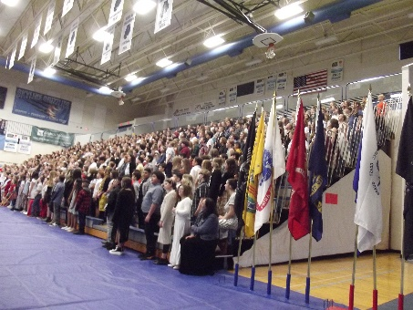
14 members of the Idaho Falls American Legion Post 56 were honored and enthusiastically participated in the stirring patriotic program. They were the flag bearers presenting the American and Idaho Flags at the conductor’s stand, lead the Pledge of Allegiance, and proudly carried and posted the flags of each of our military services.
